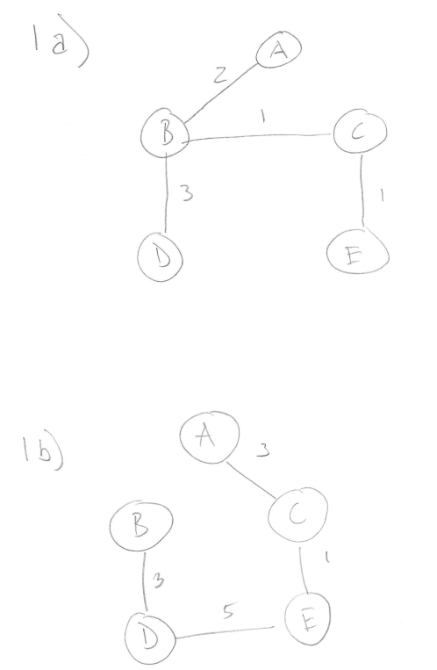

2c)

Prim’s algorithm begins at any vertex in the graph whereas Kruskal’s starts from the vertex that has the minimum cost as a edge. After it begins, Kruskal’s algorithm will only traverse each node once, whereas Prim’s can start at the same vertex more than once. Kruskal’s algorithm can woth on non-connected graphs as it can also create ‘forest’ graphs.